Work Diary Metrics

Michael

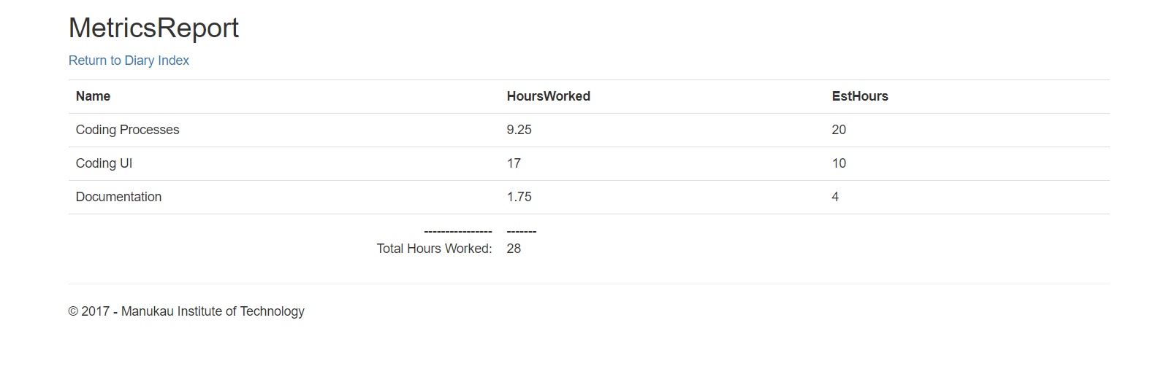

Louis